**1. Internet Basics**

**D. Listen again and complete the customer’s notes.**

To connect to the Internet from home. I need:

(1) a computer and (2) a modem

Also need an account with an (3) Interner Service Provider ISP (a company that offers connection for a monthly fee).

If you want to connect lots of computers without using cables, you can use a (4) wireless router.

Wi-Fi uses (5) radio waves to send data over medium-range distances.

Things you can do the Internet:

(6) email, newsgroup, real-time chats, looking for information on the Web.

‘Web’ or ‘Internet’? The Wec: huge collection of (7) pages stored on computers all over the word. The Internet the network whitcg connects all the computers.

**Internet FAQs: Part 1**

**How old Is the Internet (the Net)? When was it created?**

It's hard to say exactly. The research that led to what we now know as the Internet was begun in the 1960s.

**Who created the Internet?**

Again. its hard to say exactly who created a. The initial research was camed out by the Advanced Research Projects Agency in America. funded by the US government.

**Did the Internet become popular quickly?**

It took many years for the Internet to become popular around the world. It's only really since the mid-90s that the Internet has been a part of our daily lives.

**How do you get online?**

To gel connected, you need a computer. the right connection software and a modem connected to the phone line. You also need an account with an Internet Service Provider (ISP), which acts as a gateway between your PC and the rest of the Not.

**How fast are today's Internet connections?**

Today. ISPs otter a broadband, high-speed connection. The most common types are cable - offered by local cable TV companies - and ADSL (Asymmetric Digital Subscriber Line). wroth works through phone lines. They are both faster than the traditional dial-up telephone connection. Broadband access is also offered by some electricity networks This competing technology, known as power-line Internet, provides low-cost access via the power plug, but is still in development.

**How long has broadband existed?**

Since the late 1990s

**How much does broadband access cost?**

It depends on which company you choose. Nowadays, some companies even offer free broadband.

**Why do you need a modem?**

A modern (modulator/demodulator) converts digital signals into analogue signals so that data can be transmitted across the phone or cable network

**What does TCP/IP mean?**

The language used for data transfer on the Internet is known as TCP/IP (transmission control protocol/ Internet protocol). This is like the Internet operating system. Every computer connected to the Net is identified by a unique IP address.

**Are there other ways of accessing the Internet?**

Other methods of Internet access include satellite. mobile phones and TV sets equipped with a modem. WI-FI-enabled laptops or PDAs allow you to connect to the Net It you are near a wireless access point. In locations called hotspots (for example, a WI-FI cafe, park or campus). Satellite services are used in places where terrestrial access is not available (for example. on ships at sea). High-end mobile phones provide access through the phone network

**2. Internet FAQs.**

**A. Read Part 1 of the Internet FAQs on page 80 and choose correct answers.**

**1** The Internet was

**a** invented in the mid-90s. **b** popular in the 1960s. **c** probably created in the USA

**2** Which term describes any fast, high-bandwidth connection?

**a** broadband **b** dial-up connection **c** Wi-Fi connection

**3** The power-line Internet provides broadband access through

**a** telephone lines. **b** satellites. **c** electrical power lines.

**4** Which device converts computer data into a form that can be transmitted over phone lines?

**a** ADSI. **b** a mobile phone **c** a modem

**5** The standard protocol that allows computers to communicate over the Internet is called

**a** an IP address. **b** TCP/IP. **c** HTTP

6 The geographical region covered by one or several access points is called

**a** a wireless access point. **b** hotspot. **c** wireless network device.

**B. In pairs, discuss which of the internet systems (1-6) you would use to do the tasks (a-f).Then read Part 2 of the FAQs on page 81 and check your answers.**

**1** Email

**b** send a message to another person via the Internee

**2** The Web

**f** download and view documents published on the Internet

**3** Newsgroups

**e** take part in public discussion areas devoted to specific topics

**4** Chat and IM

**c** have a live conversation (usually typed) online

**5** FTP

**a** transfer files from the Internet to your hard drive

**6** Telnet

**d** connect to a remote computer by entering instructions, and run a program on it

**Internet FAQs: Part 2**

**Email**

Email lets you exchange messages with people all over the world. Optional attached tiles can include text, pictures and even audio and animation. A mailing list uses email to communicate messages to all its subscribers - that is, everyone that belongs to the list.

**Which email program is the best?**

Outlook Express is a popular program, but many users use web-based email accounts such as Hotmail.

**The Web**

The Web consists of billions of documents living on web servers that use the HTTP protocol. You navigate through the Web using a program called a web browser, which lets you search, view and print web pages.

**How often are web pages updated?**

It depends entirely on the page. Some are updated thousands of times a day

**Chat and Instant Messaging (IM)**

Chat and Instant Messaging technologies allow you to have real-time conversations online. by typing messages at the keyboard.

**FTP**

FTP, or file transfer protocol, is used to transfer files over a TCP/IP network. Nowadays. this feature is built into Web browsers. You can download programs. games and music files from a remote computer to your hard drive.

**Telnet**

Telnet is a protocol and a program used to log onto remote computer systems It enables you to enter commands that will be executed as if you were entering them directly on the remote server.

**Newsgroups**

Newsgroups are the public discussion areas which make up a system called Usenet The contents are contributed by people who post articles or respond to articles, creating chains of related postings called message threads. You need a newsreader to subscribe to newsgroups and to read and post messages. The newsreader may be a stand-alone program or part of a web browser.

**How many newsgroups are there?**

There are approximately 30.000 active newsgroups

**Where can you find newsgroups?**

Your newsreader may allow you to download the newsgroup addresses that your ISP has included on its news server. An alternative to using a newsreader is to visit web

**C Find words and phrases in Part 2 with the following meanings.**

**1** a system used to distribute email to many different subscribes at once (in Email paragraph)

mailing list

**2** program used for displaying web pages (in The Web paragraph)

Web browser

**3** to connect to a computer by typing your username and password (in Telnet paragraph)

Log into

**4** a series of interrelated messages on a given topic (in Newsgroups paragraph)

message thread

**5** a program for reading Usenet newsgroups (in Newsgroups paragraph)

newsreader

**3. Language work: questions**

**A Look at the HELP box and then make a question about Sue Clarke for each of her answers**

**1** How old are you?

I’m 23 years old.

**2** What’s your job?

I’m an online researcher.

**3** What do you do in your job?

I use the internet to find information requested by clients**.**

**4** How long have you been doing this job?

I’ve been doing this job for six months.

**5** When did you been doing this job?

I graduated from university in 2006.

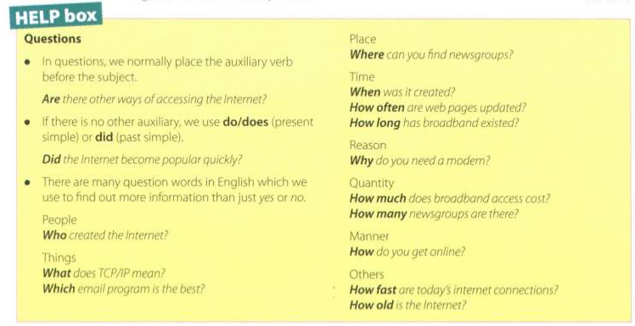

**B. In pairs, make questions using these prompts. Then practise asking and answering the questions.**

Example: When / first / use the Internet When did you first use the Internet?

**1** What type of internet connection / have at home?

What type of internet connection do you have at home?

**2** How fast / your Internet connection?

How fast is your internet connection?

**3** How much / pay for broadband access?

How much do you pay for broadband access?

**4** glow often / access the Internet?

How often do you access the Internet?

**5** Which email program / use?

Which email program do you use?

**6** Who/send email to?

Who do you send email to?

**7** Do / use your mobile phone to access the Internet?

Do you use a mobile phone to access the Internet?

**8** Do / use the Internet in public spaces using Wi-Fi?

Do you use the Internet in public spaces using Wi-Fi?

**9** Do / play games online?

Do you play games online?

**10 How many newsgroups do you subscribe to?**

Now many newsgroups / subscribe to?

**Email features**

When you set up an account with an Internet ServiceProvider, you are given an **email address** and a **password.** The mail you receive is stored on the **mail server** of your ISP - in a simulated mailbox - until you next connect and download it to your hard drive.

There are two ways to get email over the Internet. One is by using a **mail program** (known as **email client** installed on your computer, for example Eudora or Outlook Express. The other way is to use **web-based email** accessible from any web browser. Hotmail and Gmail are good examples.

You can make the message more expressive by including **emoticons**, also called **smileys**. For example, ;-) for wink, :-) for happy, :-o for surprised. :-D for laughing. etc. You may also like to add a **signature file**, a pre-written text file appended to the end of the message. The name given to unsolicited email messages is **spam.**

